12. To classify Iris flowers using the K-Nearest Neighbours (KNN) algorithm.
Procedure
- Import the Iris dataset and KNN classifier.
- Load the Iris dataset.
- Train the KNN model using the training data.
- Predict the flower class.
- Display the predicted result.
Dataset 1: Fruit Classification
Weight (g) | Diameter (cm) | Sweetness (%) | Fruit
150 | 7.5 | 90 | Apple
160 | 7.8 | 88 | Apple
145 | 7.3 | 91 | Apple
120 | 5.5 | 70 | Orange
125 | 5.8 | 72 | Orange
130 | 6.0 | 74 | Orange
155 | 7.6 | 89 | Apple
118 | 5.4 | 69 | Orange
148 | 7.4 | 92 | Apple
122 | 5.7 | 71 | Orange

Code and Output;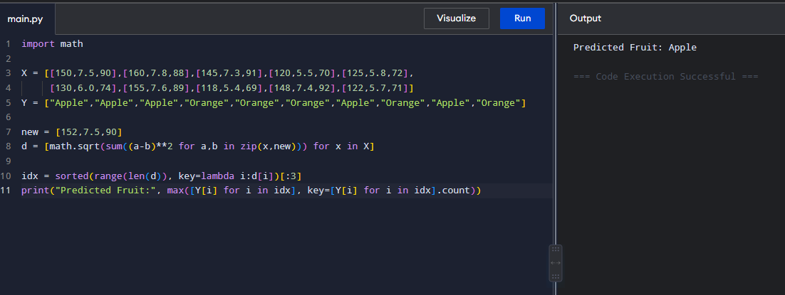

Dataset 2: Student Placement Classification
CGPA | Aptitude Score | Communication Score | Placement
9.2 | 90 | 88 | Placed
8.8 | 85 | 82 | Placed
8.5 | 80 | 79 | Placed
7.2 | 72 | 70 | Not Placed
6.8 | 68 | 65 | Not Placed
9.0 | 92 | 90 | Placed
7.5 | 75 | 74 | Not Placed
8.6 | 84 | 81 | Placed
6.5 | 60 | 58 | Not Placed
8.9 | 88 | 86 | Placed

Code and Output:
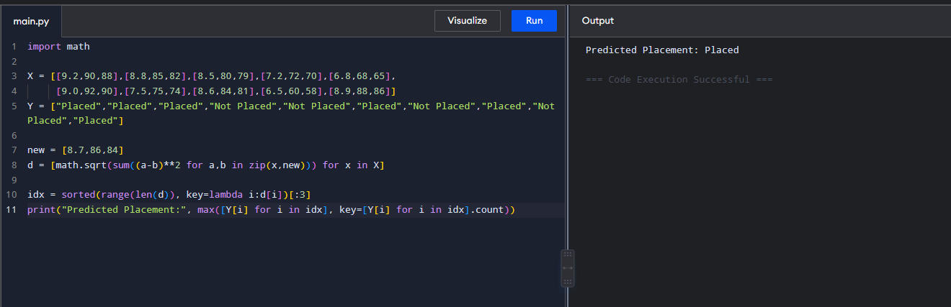

Dataset 3: Disease Diagnosis
Temperature (°C) | Heart Rate (bpm) | Oxygen Level (%) | Disease
39.0 | 110 | 94 | Positive
38.5 | 108 | 95 | Positive
37.0 | 78 | 99 | Negative
39.2 | 115 | 93 | Positive
36.8 | 75 | 98 | Negative
38.8 | 112 | 94 | Positive
37.2 | 80 | 98 | Negative
39.1 | 114 | 92 | Positive
36.7 | 74 | 99 | Negative
38.9 | 111 | 93 | Positive
Code and Output:
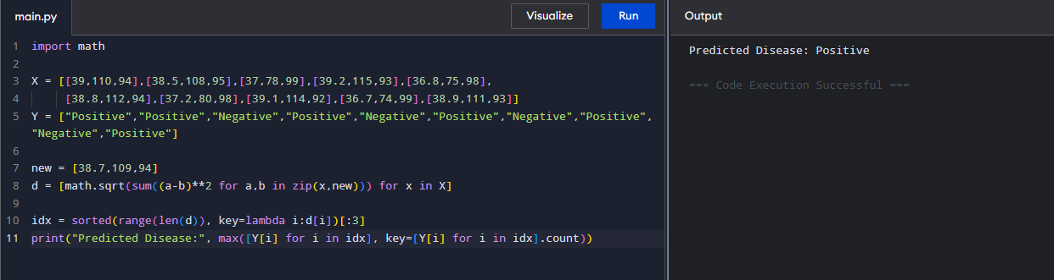
Dataset 4: Employee Promotion Prediction
Experience (Years) | Performance Score | Training Hours | Promotion
10 | 95 | 50 | Promoted
8 | 90 | 45 | Promoted
7 | 88 | 40 | Promoted
3 | 65 | 20 | Not Promoted
2 | 60 | 18 | Not Promoted
9 | 93 | 48 | Promoted
4 | 70 | 25 | Not Promoted
8 | 89 | 42 | Promoted
2 | 58 | 15 | Not Promoted
6 | 85 | 38 | Promoted

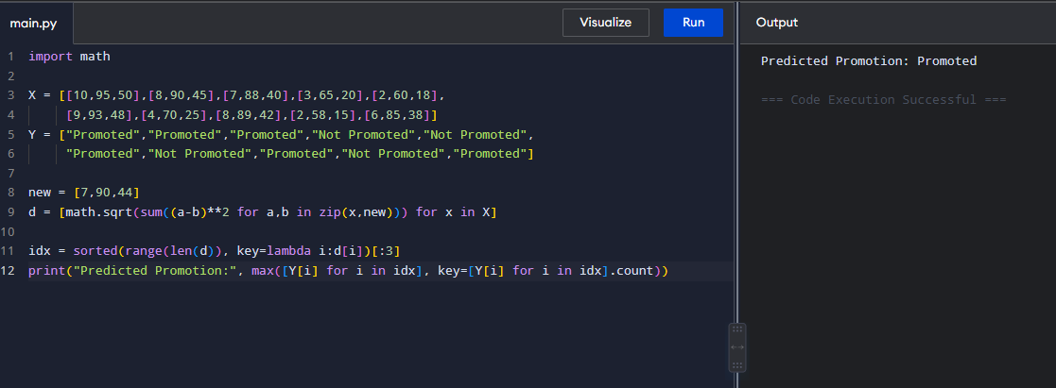

Dataset 5: Vehicle Classification
Engine Capacity (cc) | Weight (kg) | Mileage (km/L) | Vehicle Type
100 | 95 | 70 | Bike
125 | 110 | 65 | Bike
150 | 125 | 55 | Bike
800 | 850 | 22 | Car
1000 | 950 | 20 | Car
1200 | 1050 | 18 | Car
110 | 100 | 68 | Bike
900 | 900 | 21 | Car
140 | 120 | 58 | Bike
1300 | 1100 | 17 | Car

Code and Output:
